INDEXU 7
Custom Field Types

By Dody Rachmat W. (dodyrw@gmail.com)
September 7, 2011

One of Indexu 7 strength point is the flexibility of defining custom fields for your directory project. You can add as many as data fields as you desire. This tutorial will cover the custom field types.
Custom field types represent how the data field will interact with the user.

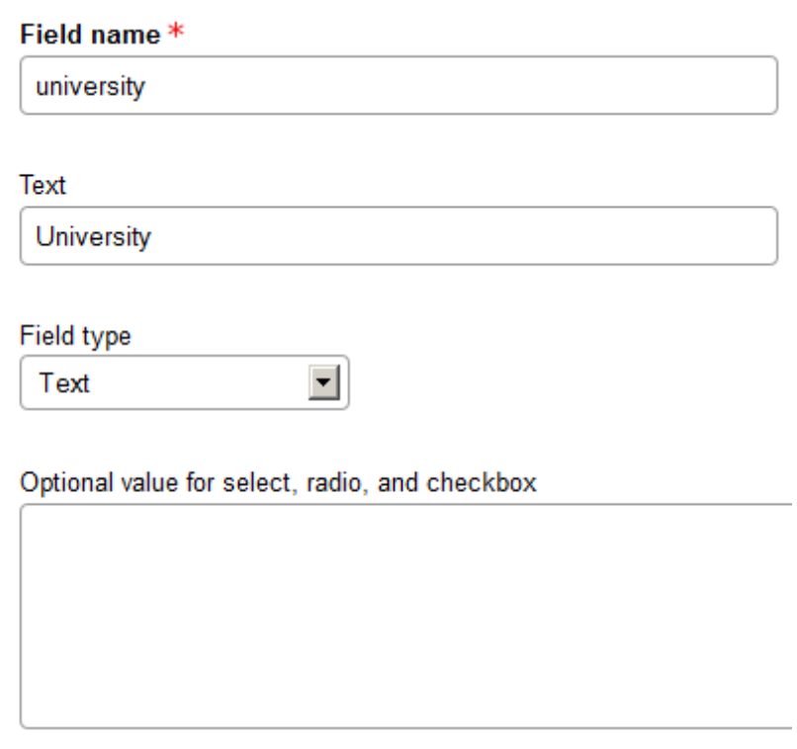
- Text
Admin panel setting :
Result :
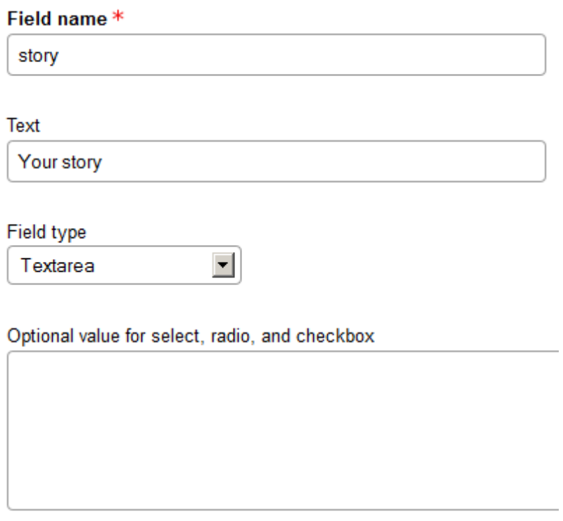

- Textarea
Admin panel setting :
Result :

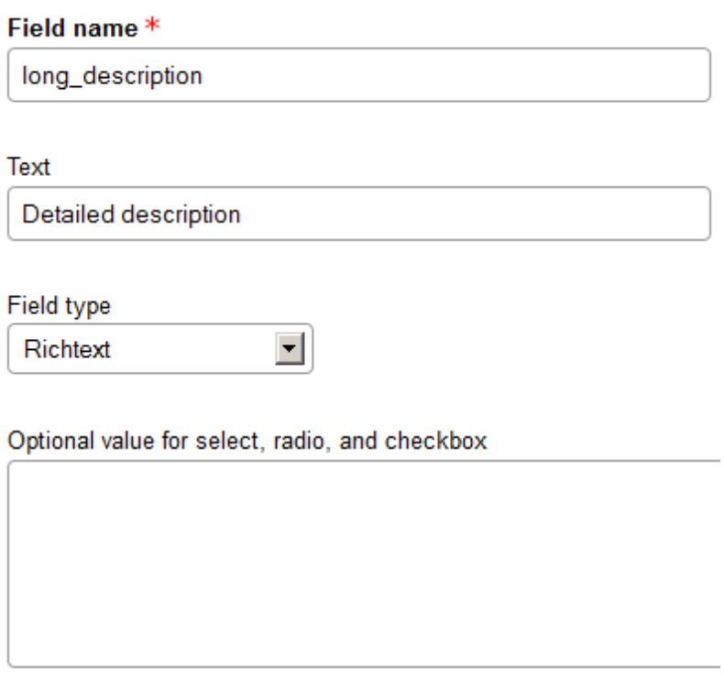
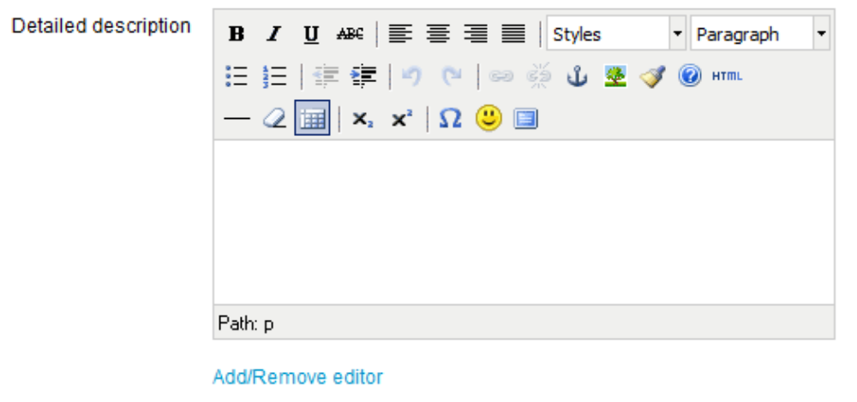
- Richtext
Admin panel setting :
Result :

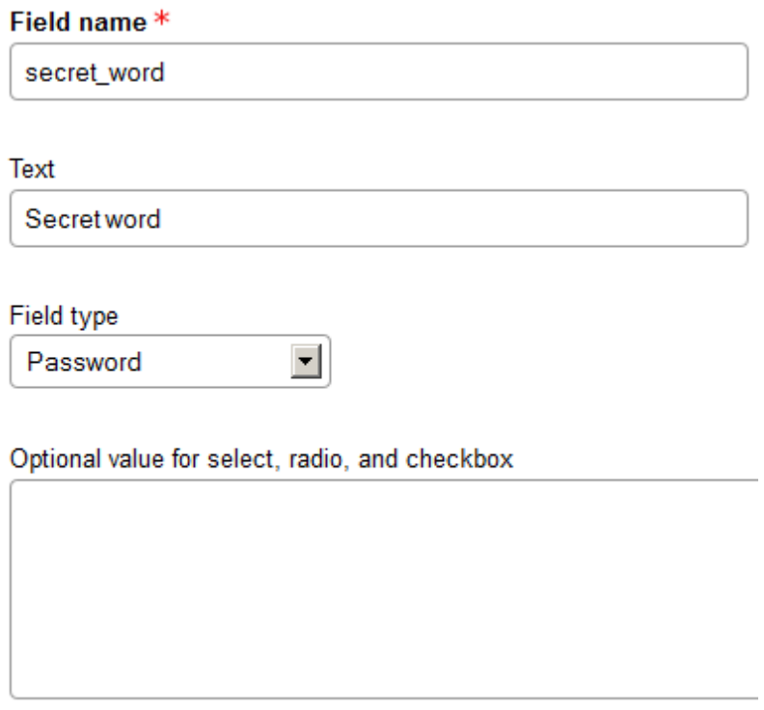
- Password
Admin panel setting :
Result :

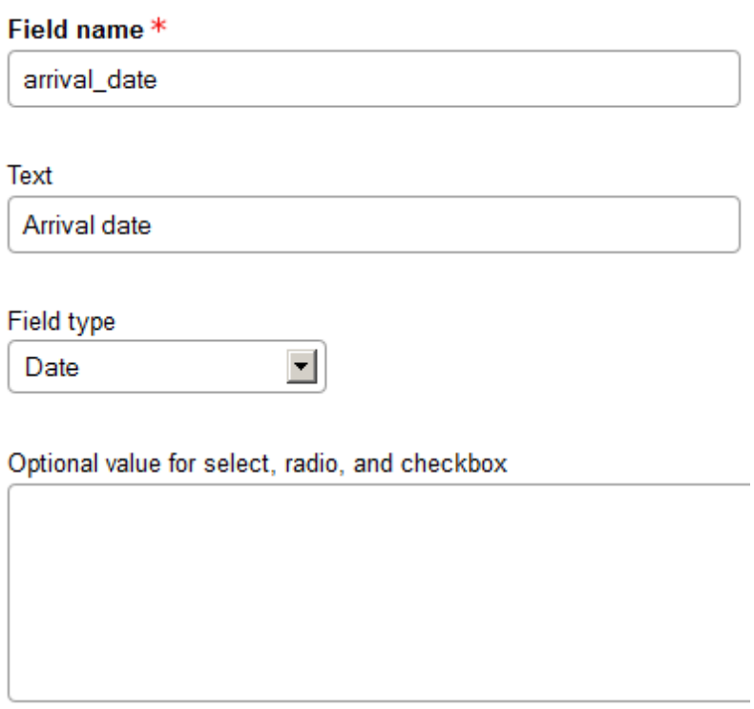
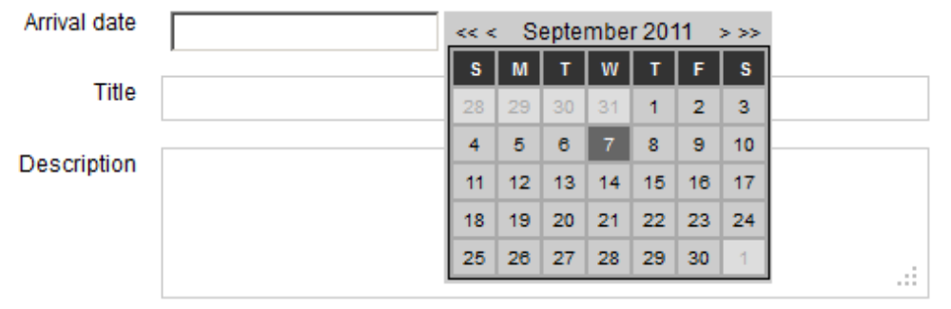
- Date
Admin panel setting :
Result :

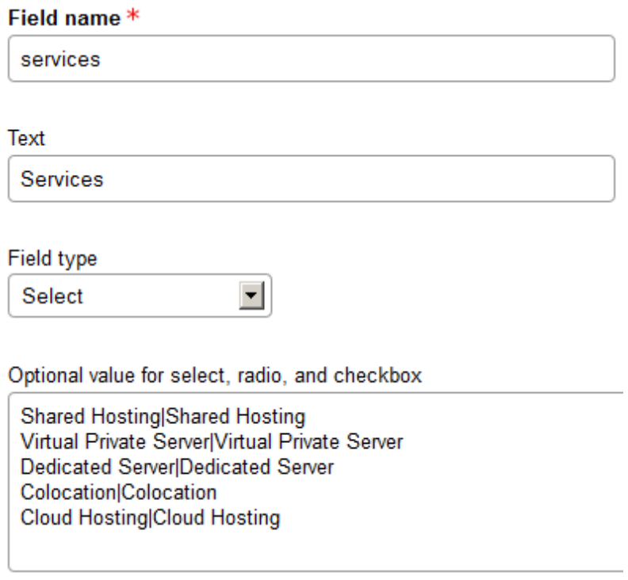
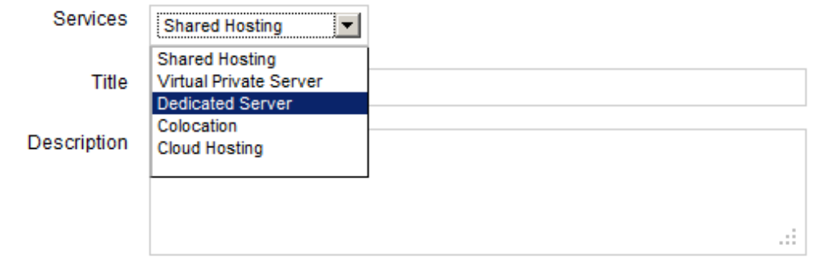
- Select
Admin panel setting :
Result :

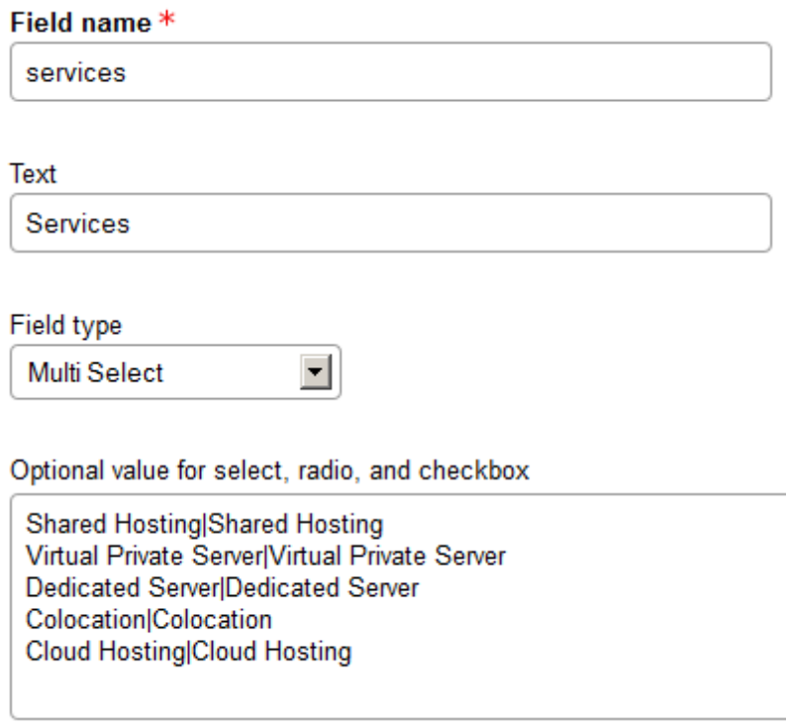
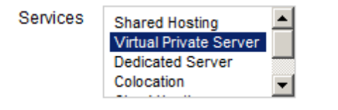
- Multiselect
Admin panel setting :
Result :

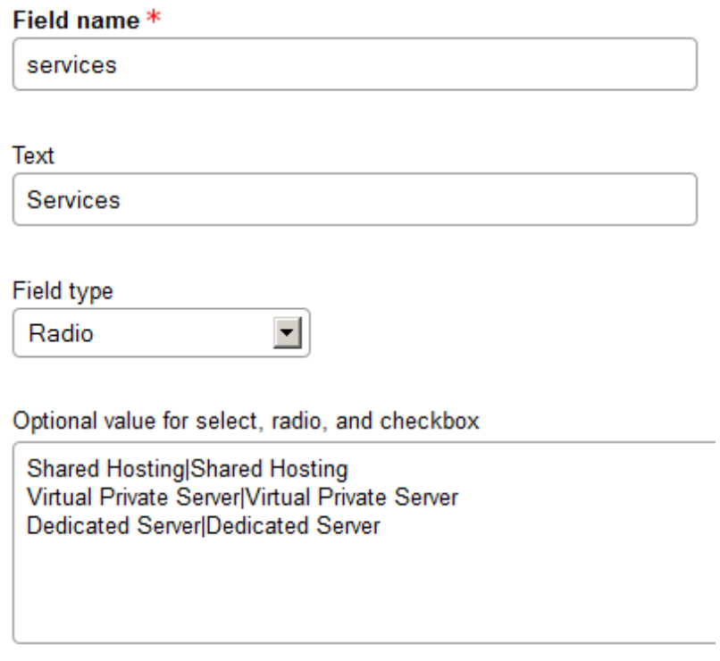
- Radio
Admin panel setting :
Result :

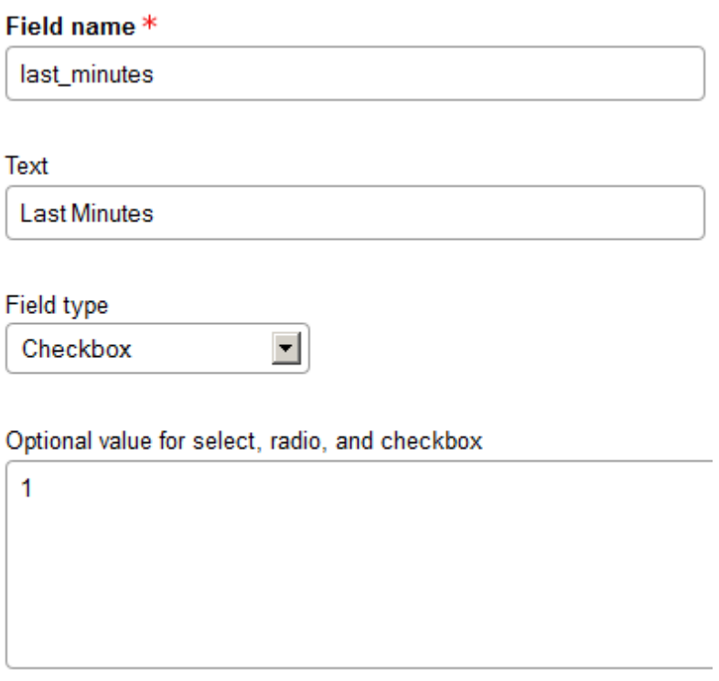

- Checkbox
Admin panel setting :
Result :

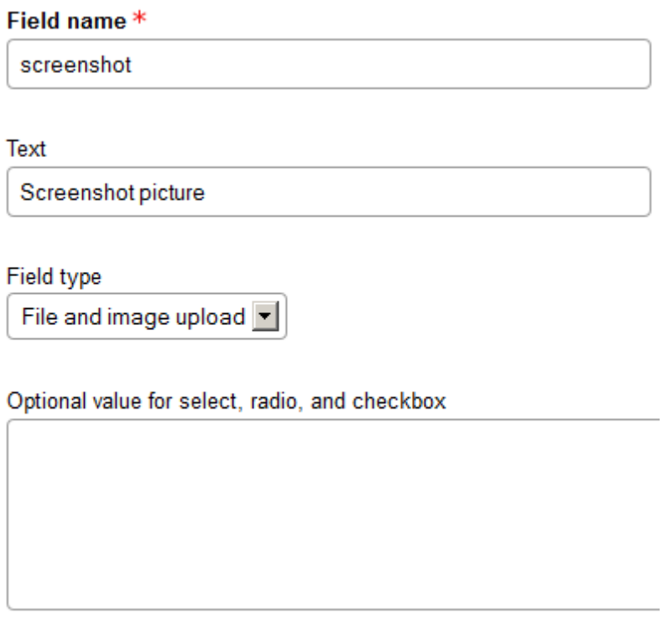
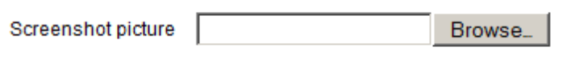
- File and image upload
Admin panel setting :
Result :

